Online Video Streaming

Using Cloud Computing

|  |  |  |
| --- | --- | --- |
| Dr. Narendra Rao  Head of Department, Dept. of CSE  Mohan Babu University (Erstwhile Sree Vidyanikethan Engineering College),  Tirupati, India | Dr. K. Padmaja  Associate Professor, Dept. of *CSE*  Mohan Babu University (Erstwhile Sree Vidyanikethan Engineering College),  Tirupati, India | Gorantla Sahithi  UG Scholar, Department of CSE  Mohan Babu University (Erstwhile Sree Vidyanikethan Engineering College),  Tirupati, India |
| Nalathati Siddaradha  UG Scholar, Department of CSE  Mohan Babu University (Erstwhile Sree Vidyanikethan Engineering College),  Tirupati, India | Padiri Devi Sree  UG Scholar, Department of CSE  Mohan Babu University (Erstwhile Sree Vidyanikethan Engineering College),  Tirupati, India | Vennapusa Saketh Reddy  UG Scholar, Department of CSE  Mohan Babu University (Erstwhile Sree Vidyanikethan Engineering College),  Tirupati, India |

***Abstract* --** **With the rise in the widespread use of video streaming, people can now watch films on a range of devices, including laptops, wide-screen TVs, and smartphones, in addition to tablets. It is presently ubiquitous and flexible due to the integration of technological advances like cloud computing, compression of videos, and networks for delivering content. Given that video streaming makes up a significant amount of Internet traffic, it is imperative to comprehend how these technologies connect and function. This aims to make public the intricate processes involved in packing, encrypting, delivering, transcoding, and video encoding unfiltered video to users' devices. Considering how much the market for streaming videos is relying on cloud-based software, it also looks into the usage of cloud services to provide video streaming services.** **To help the industry shift to a more flexible and user-focused offering, the report also attempts to locate research projects in the field of cloud-based video streaming and anticipate future challenges.**

**Keywords: user-focused offering, content delivery networks, cloud computing, encryption, transcoding, video streaming, and internet traffic.**

# INTRODUCTION

***VOD-***

The idea of streaming video content was first introduced with the development of television in the early 1900s. Video streaming has been the most popular type of internet traffic during the last ten years as people's methods of consuming and receiving video content have changed dramatically from traditional television to streaming via the Internet on many devices. Over 60% of all Internet traffic is now made up of video streaming, according to a survey by Global Internet Phenomena [1]. In the United States, the number of Netflix1 users has already eclipsed that of subscribers of cable TV [2]. Many web-based apps these days rely on streaming video. User-generated video material is available through apps like Vimeo and YouTube, while (OTT) over-the-top streaming is offered by Netflix and Amazon Prime, live streaming and personal broadcasting are offered by Facebook Live and UStream, e-learning platforms [3] (similar to those on Udemy7), live game streaming platforms [4] (similar to those on Twitch8), video chat and conferencing systems [4], video surveillance-based security and natural disaster management systems [5], and network-based broadcasting channels [6] (similar to those on news and other TV channels).

The increasing demand for computing services for streaming video is a result of the growing popularity of these services. Cloud computing technology is becoming more and more common, with it, streaming's popularity and adoption. A vast array of computing services are offered by cloud providers, enabling consumers to outsource their requirements and spare video streaming companies the cost and trouble of upgrading and maintaining costly infrastructure[7]. The majority of video stream providers' computational needs are currently met, if not entirely, by cloud services [8]. The computer industry has seen new problems and creative solutions as a result of the integration of cloud services and video streaming.

There has been a lot of study done on cloud-based video streaming, but as of right now, no thorough analysis of the problems, solutions, and technologies involved in this field is accessible. Thus, the primary objectives of this research are to: (1) elucidate the intricate processes required for broadcasting video over the Internet; (2) present a thorough rundown of how video stream providers can benefit from cloud services; (3) give a comprehensive summary of the research projects carried out at the intersection of cloud computing and video streaming; additionally (4) discuss the potential directions that industry and academic research may want to pursue to advance cloud-based video streaming technology.

As a result, we describe how video streaming operates and detail each step of the process in this study. Next, we present a comprehensive analysis of the difficulties and requirements facing the contemporary market of video streaming in Section 1.3. An overview of the research on how cloud services can help with the requirements of streaming videos can be found in Section 1.4. Finally, we address the cutting-edge fields of study at the nexus of cloud computing and video streaming in Section 1.5.

***Video Streaming using Cloud Computing-***

To guarantee good QoE (Quality of Experience) for a broad audience with a variety of screens and network setups, suppliers of video streams use pre-processing techniques like pre-transcode and pre-package, allowing for a variety of watching experiences [9]. As a result, viewers using various display devices may quickly identify the version that works with them. Lazy (or on-demand) video processing is an alternate technique of pre-processing videos [9,7]. Recent investigations based on the statistical trends of video stream access[10] within a repository have demonstrated that this strategy is especially useful for videos that are not viewed frequently. As a matter of fact, video streaming has a lengthy tail [11]. This suggests that while a minor portion (about 5%)of the videos—often called “hot video streams”—can be accessed often, a significant number of video streams are viewed infrequently. The video streaming source must have a large processing capability in order to use both the pre-processing and on-demand approaches.

Due to the requirement for networking, storage, and processing power, maintaining and upgrading internal infrastructure for video stream providers can be expensive. Furthermore, it differs technically from the main line of business of stream suppliers of producing and publishing video content. Yet, cloud service providers, such as Amazon Cloud(AWS), Google Cloud, and Microsoft Azure can fulfill these requirements by providing effective high-availability services[12]. Providers of Video stream now rely mostly, if not entirely, on cloud services to meet their computational needs. For example, Netflix has completely outsourced all of its computing needs to Amazon Cloud [13]. Video stream providers now face additional obstacles in deploying cloud services, despite the numerous advantages. Because users are charged by cloud providers on a pay-as-you-go basis, stream providers must find ways to reduce their cloud expenses while ensuring a high standard of experience for their audience [14]. Numerous research projects have been completed to address the difficulties connected to utilizing cloud services for video streaming. For example, the price of using cloud services to convert videos into another format [15,12], a comparison of the costs and benefits of several video segmentation models [16,9], the use of specialized scheduling techniques to perform video streaming duties [17,15], this text discusses the methods and strategies for provisioning virtual machines as resources for streaming videos [9,18] have all been examined by researchers. Nevertheless, most of these studies concentrate on a particular feature of processing video streaming and how it could act effectively managed in the cloud. To put these efforts in a broader context and offer a clearer vision for the efficient usage of cloud services throughout the video streaming workflow, more research is necessary.

LITERATURE SURVEY

Researchers have looked into cloud-based video streaming architectures and solutions , yet, every project that has been completed thus far has made use of a streaming server or processing server, both of which require constant uptime in order to receive video data from recording devices.

The study by aims Shi, Y., Sun, and Pan, J. [19] to continuously predict subjective QoE, or quality of experience for wireless streaming of video in real-time using a hybrid prediction model and dynamic feature selection. The results show average prediction accuracy within 0.15 subjective score points, improved QoE monitoring, and reduced overhead. However, limitations include limited user feedback, model training, and need for further research to integrate QoE prediction with robust adaptation mechanisms for diverse network conditions.

EmuStream[20] is an end-to-end platform designed for accurate and reproducible measurement of streaming video performance under diverse network conditions. The platform emulates network conditions, adaptive streaming algorithms, and client behaviors. It also develops a segment size model to estimate segment sizes for various bitrates. The results show high accuracy, reproducibility, and flexibility. However, potential overhead, model limitations, and continuous refinement are challenges. The platform supports diverse network conditions, encoding profiles, and client behaviors.

The study by J.Sole, D.R. Bull, and A.V.Katsenou [21] aims to create an effective bitrate ladder for streaming videos that adapts, reducing encoding costs while maintaining quality. They used machine learning prediction, Pareto Front Estimation, and a hybrid approach. The results showed significant encoding reduction, minimal quality loss, and improved efficiency. However, the study has drawbacks such as model dependence, potential overhead, and the need for continuous refinement for changing content or encoding standards.

Z. Shang, J. P. Ebenezer, Y. Wu, H. Wei, S. Sethuraman, and A.C. Bovik [22] conducted a study looking into the high-motion live streaming videos' subjective and objective quality.. They created a database, assessed subjective quality with viewers, and used objective metrics. The study found distortions like motion blur and stutter impacting perceived and measured quality, and identified trade-offs between bandwidth, resolution, and encoding settings. However, the study has limitations, including limited research scope, potential bias in subjective evaluations, and the need for further validation of objective metrics.

R. Wang, L. Si and B. He [23], developed a novel correction of forward errors (FEC) scheme for streaming videos in real time, focusing on reference picture structure. The scheme assigns higher priority to reference pictures and strategically distributes redundancy across frames. The results showed improved error resilience, video quality, and reduced delay. However, drawbacks include overhead, complexity, and need for further research.

The study by J. Lee, S. Kim, J. -Y. Jung, J. Tanjung, J. -D. Kim, and D. -H. Kim [24] aim to improve QoE, or quality of experience in Multiview video streaming using HTTP-based dynamic adaptive streaming. The methods include view popularity prediction, adaptive rate allocation, and buffer management. Results show a 50% decrease in stalling duration, a 15% increase in overall QoE, and enhanced efficiency. However, the study has drawbacks such as prediction accuracy and implementation complexity. Further evaluation requires real-world testing with diverse content and network conditions.

In summary, the literature survey describes how researchers have investigated streaming videos from the cloud architectures and solutions, but most work has focused on streaming servers or processing servers. A solution for video surveillance systems uses a client program that gathers video data from IP cameras and transmits it to servers for processing. While there hasn't been much in the way of performance modeling and evaluation for video transcoding, GPU-cloud resources that are enabled are faster for superior live streaming applications. Other studies explore P2P architectures, binary tree strategies, VOD networks, and more. QoE, or quality of experience is a crucial metric for video streaming services.

# PROPOSED METHODOLOGY

1. ***Steps for Cloud based Video Streaming –***

The content of video generated by cameras must pass through several intricate steps in both video on demand(VOD) and live streaming(livestream9) (Hulu, YouTube, Netflix) before it can be viewed on viewers' devices.

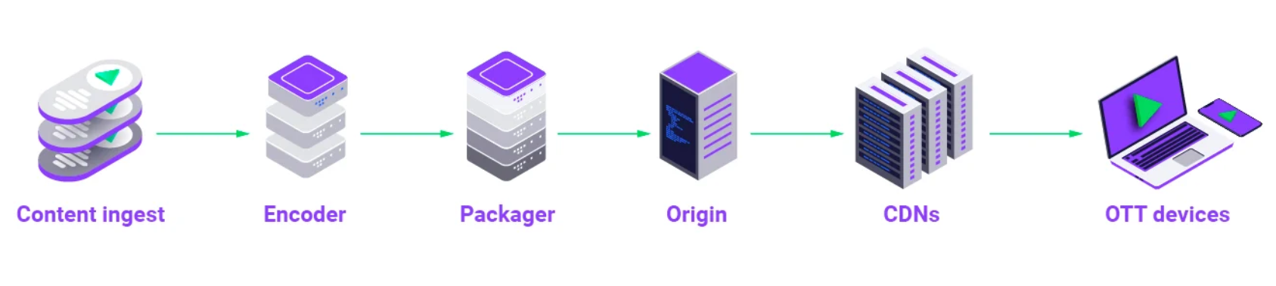***Figure 1:*** Workflow of Video Streaming

1. ***Video Transcoding***

Video transcoding is a crucial process for video streaming, requiring significant processing power and time. Previously, streaming service providers had to operate large computer systems or internal data centres. However, many have outsourced their transcoding operations to cloud servers due to the high processing overhead. As a result, cloud-based services for video transcoding have been developed, which can be based on pre-transcoding or on-demand transcoding. On-demand transcoding is becoming more popular because of the long-tail access patterns to online video streams. Partial pre-transcoding, which involves pre-transcoding only a few key portions of a video stream, is a more efficient method. Despite expenses related to processing and preserving view metadata for every GOP, research concentrates on resource allocation, load balancing, and video segmentation to boost efficiency in pre-transcoding processes. Understanding how different virtual machine types perform differently is essential for effective use of cloud services. GOP frame numbers have the greatest influence on transcoding time, and small GOPs can maintain performance even on inexpensive virtual machine types.

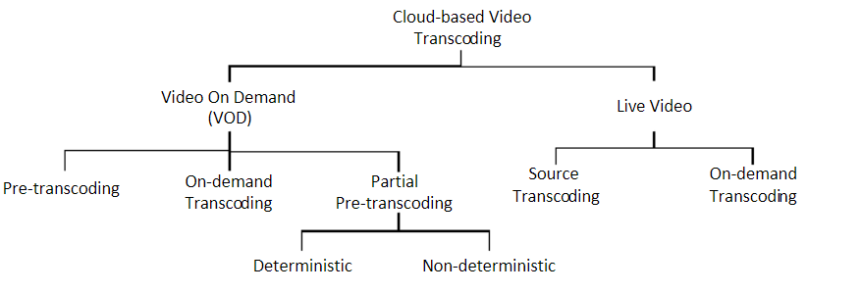

***Figure 2:*** Methods for transcoding videos with cloud services.

Li et al. propose an appropriateness model for different transcoding tasks, focusing on cost and performance. Denekeet al. use machine learning to forecast transcoding time based on video attributes. To lower the cost of on-demand video transcoding, Li et al. suggest using a cloud-oriented video streaming engine (CVSE). Reduced startup latency and minimal jitter are the optimal quality of experience (QoE) metrics. For cloud-oriented video transcoding, Jokhio and colleagues describe an exchange-off strategy to maintain equilibrium processing and expenses of storage. Zhao and colleagues take into account the video's popularity, while Darwich and colleagues provide a technique for partially pre-transcoding video streams according to their level of sexiness. In order to encode videos more cheaply, Barais et al. suggest using a microservice architecture. Denninnart et al. suggest aggregating comparable or identical streaming micro-services to mitigate computational expenses. Live streaming has also made use of cloud-based video transcoding, with Laiet al. providing transcoding in real-time with the use of the cloud and an architecture for streaming-as-a-service and live transcoding described by Timmerer et al.

1. ***Video Packaging***

Since video packaging requires less computing power than video transcoding, processing videos spontaneously with cloud-based offerings (VMs or containers) is more advantageous and practical [25]. Video content for video-on-demand (VOD) streaming is typically pre-transcoded into multiple interpretations (formats), after which every performance is bundled into multiple variations to satisfy the specifications of various streaming protocols (e.g., DASH, HLS, Smooth). Video snippets are packaged dynamically according to the protocols backed up by the device, as opposed to arranging transcoded videos statically into several protocol formats and storing them in the repository (i.e., pre-packing). Although the entire process only takes a few milliseconds [26], viewers usually aren't aware of it, and video streaming providers benefit from a significant reduction in storage costs. Container services are typically implemented in cloud data centers because of how simple packing process is.

1. ***Delivery networks based on the cloud and latency in video streaming***

High latency connectivity to consumers and centralization are two characteristics of clouds [27]. Material delivery networks frequently store video material in caches(CDN) like Akamai, and AWS_cloudfront to minimize network latency and the number of requests coming in from the hosting systems. The CDNs are dispersed throughout the region close to the viewers. The figure depicts the workflow for the entire video streaming procedure. A web server in the cloud data center receives the request from a viewer to stream a video first. The web server will return a manifest document that tells the computer of the audience which CDN contains requested video files if the file is already cached there. Subsequently, the viewer requests to stream the video again from the content delivery network. If the requested video is not already cached in the CDN, the web server needs to process it and from cloud storage to the CDN. A proposal by Jin et al. [28] provides user-generated content providers with an on-demand virtual content delivery service to distribute their content to viewers.

A hybrid cloud was used in the development of the suggested method. By employing virtual content distribution services and retaining the QoE for user-generated content

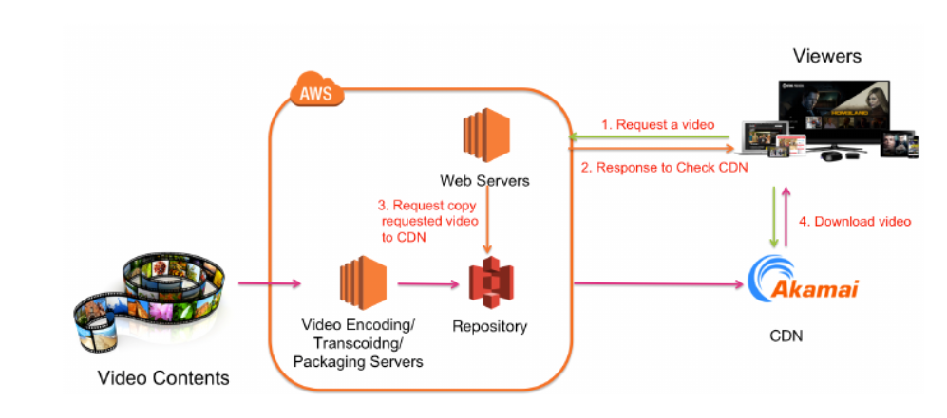

***Figure 3:*** Process of actions carried out for streaming videos with reduced latency.

providers, their approach provided elasticity and anonymity. A hybrid cloud deployment strategy for VoD partial migration was put forth by Li et al. [29]. Their suggested technique enables users' requests to be partially fulfilled by using cloud computing and partially by using servers they own. When comparing the client/server mode to the hybrid cloud migration approach, bandwidth costs can be reduced by up to 30% thanks to the combination of proactive, reactive, and intelligent techniques. To show the perks of CDN incorporation with the cloud, Microsoft researchers ran an experiment on Windows Azure, the company's public cloud CDN. The findings indicate that using CDN in cloud computing significantly increases huge data download speeds. [30]

1. ***Cloud Storage for Video Streaming***

Big video data is a challenge brought on by the quick rise in the use of video streaming on mobile devices (e.g., laptops, tablets, and smartphones) and in a variety of applications, including situational awareness, video surveillance, and e-learning [31]. Enormous storage facilities are needed due to the rapid expansion of video material on the Web. The high cost of administration and maintenance for storage hardware, however, is matched by problems with scalability and dependability that plague the current server farms. Scalability, fault tolerance, and dependability are all addressed by the services of cloud storage [32]. Major streaming services (like Hulu and Netflix) have thus used cloud storage services exclusively to meet their requirements for video storage.

***Figure 4:*** A comparative analysis of various systems for video stream storage.

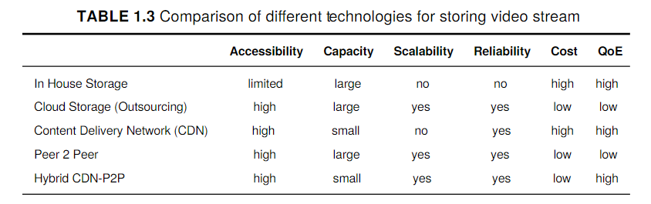

Regarding the availability of a single video stream to viewers, available storage space, scalability, dependability, affordability, and quality of service, Table 1.3 compares many storage options for video streaming. Notably, by caching momentarily hot video streams, CDN can be used to lower storage costs even though it is not a storage solution. One effective method of reducing storage capacity and cost is through streaming video processing on-demand, which is why we have included it in our comparison table.

This becomes much more critical when taking into account the long-tail access behavior to video streams [33]. A cloud-based method for partially pre-transcoding video footage is proposed by Gao et al.; this approach reduces storage costs by 30% when compared to pre-transcoding the complete stream. In light of both long-tail distribution and random-access patterns, Darwich et al. suggest a cost-effective and storage-efficient approach regarding cloud-hosted video streaming databases that utilize long-tail access patterns.

To minimize startup latency, Krishna et al. suggest ways to transcode user-requested portions of a video stream. They do this by applying Markov theory to forecast the next requested video segment. With remarkable accuracy, this method lowers cloud storage expenses significantly.

1. ***Role of AWS Services in VOD-***

Using the AWS Cloud, Video on Demand employs a cost-effective method to distribute video-on-demand (VOD) content to audiences worldwide. It offers multiple functionalities and provisions the AWS services needed to create distributed, scalable workflows for VOD processing and delivery.

1. Amazon Step Manages the workflow's ingest, transcoding (including pre-and post-processing), and publication phases.
2. Selecting a trigger from a video file or metadata file.
3. Using Amazon CloudFront, viewers can receive films that are prepared for a variety of devices.
4. An automatic video input archive to lower storage expenses
5. ***AWS Components***
6. The Amazon S3
7. Lambda AWS
8. CloudWatch by Amazon
9. The Simple Notification Service on Amazon
10. CloudFront by Amazon
11. ***Functionalities of AWS services***

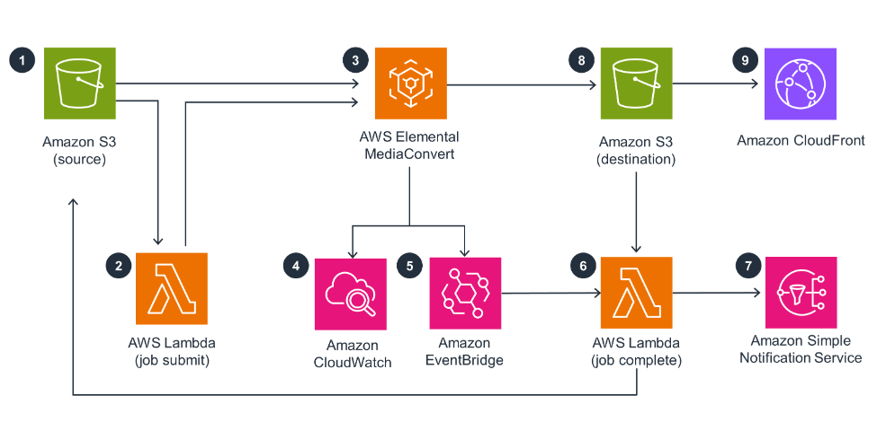***Figure 5:*** AWS Cloud Formation.

**Step 1:**

The solution uploads a sample job settings file to the S3 bucket on Amazon, specifying the encoding parameters for Amazon Elemental MediaConvert.

**Step 2:**

The encoding jobs in MediaConvert are created using an AWS Lambda job submit function.

**Step 3:**

Pre-recorded videos can be expertly converted by MediaConvert into a variety of formats that are ideal for on-demand playback across a range of platforms and devices.

**Step 4:**

In VOD, Amazon CloudWatch keeps an eye on interaction, encoding, video delivery, and system health. It offers critical data for enhancing viewer experience and performance optimization.

**Step 5:**

Amazon EventBridge invokes Lambda task completion.

**Step 6:**

An output function in a Lambda job completes the processing.

**Step 7:**

Notifications of completed jobs are transmitted using a topic regarding Amazon Simple Notification Service (Amazon SNS).

**Step 8:**

The MediaConvert outputs are stored in a destination S3 bucket.

**Step 9:**

The destination S3 bucket is set up in Amazon CloudFront as the origin for the worldwide delivery of the transcoded video material.

AWS provides D2C and streaming services for leading companies like Netflix, HBO Max, Peacock, Discovery+, HULU, and Prime Video. With over 15 years of experience, AWS offers broadcast-quality live video processing and transcoding services, and over 60 AWS Partners offer tools for streaming and D2C workloads.

1. ***Outcomes of using CDN by VOD platform-***

Multiple components make up a website, including movies (.mp4), photos (jpg, gif), and code (HTML, JavaScript, CSS). Worldwide traffic is directed towards brands, and load times are contingent upon the location of the servers. To ensure faster website loading times, Material Delivery networks (CDNs) distribute static content based on end-user proximity across a globally distributed network of proxy servers. As well as improving backend features like picture compression, session optimization, and increased site stability by lowering traffic spikes at the origin, content delivery networks (CDNs) improve user experience by rapidizing page loading.

***Figure 6:*** The image depicts the difference between how the platform works without CDN and with CDN.

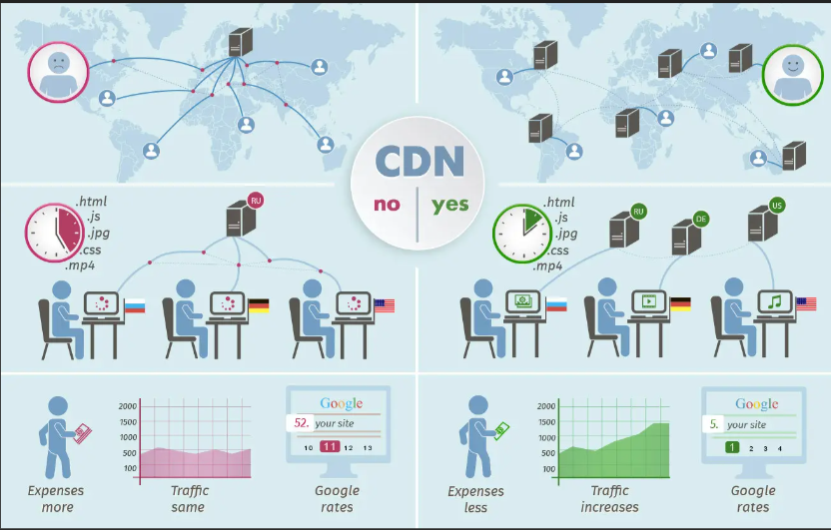

With its wide worldwide network of edge sites, CloudFront CDN is essential for cutting down on latency when streaming videos. To minimize latency and data transit, these locations are grouped closer to the viewers. CloudFront achieves fast

delivery and lower latency by storing frequently visited information in a cache at this edge locations. Rather than having to retrieve them from the origin server, this enables popular videos or segments to be served Straight from edge.

***Figure 7:***  CDN performance in reduction of latency

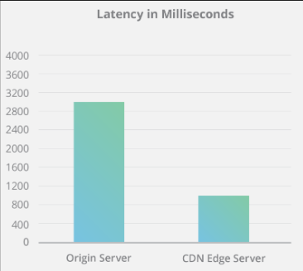

CONCLUSION

Streaming video is among the most widely used online services, which are taking up the majority of traffic on the Internet. An extensive range of technologies, from production technologies for video streaming to methods for displaying them on different kinds of screens, are required to deliver a high-quality and continuous video streaming service. Since cloud services have become more and more prevalent over the last ten years, video streamers have mostly become dependent on the services that the clouds offer. The first version of this document included the procedure and every technology needed to broadcast a movie online. We gave viewers a high-level overview of how these technologies work together to produce a great viewing experience.

Second, we gave an overview of each of those technologies as well as the difficulties that practitioners and researchers in the field of video streaming are facing. Third, we looked at how different cloud services may be combined to meet the needs of streaming video services. We compiled and arranged the various studies that have been conducted in this field. Briefly stated, serverless computing, often known as function, virtual machine, or container paradigms, is the main use of the cloud.

Computational services can be used for stream analytics, video transcoding, video packaging, and video encryption;(B) With cloud-based Content Delivery Networks(CDN), cloud network services reduce latency in video streaming regardless of the viewers’ location; and (C) to keep up repositories for streaming media and enable the persistence of multiple copies of every video to accommodate various viewing devices, cloud storage services are utilized. The Platform revolutionizes the cross-industry video streaming landscape by going beyond entertainment. Beyond the world of films and television series, we provide customized platforms for a range of industries, including healthcare, education, fitness, and more. Through tailored information, engaging tools, and flexible access, this platform empowers users and transforms the way we obtain basic services and pursue personal growth in a variety of industries.

##### REFERENCES

[1] Vijay Kumar Adhikari, Yang Guo, Fang Hao, Matteo Varvello, Volker Hilt, Moritz

Steiner, and Zhi-Li Zhang. Unreeling netﬂix: Understanding and improving multi-

cdn movie delivery. In Proceedings of the IEEE International Conference on

Computer Communications, INFOCOM ’12, pages 1620–1628, 2012.

[2] Michael M Afergan, F Thomson Leighton, and Jay G Parikh. Hybrid content

delivery network (cdn) and peer-to-peer (p2p) network, Dec. 2012. US Patent

8,332,484.

[3] Ishfaq Ahmad, Xiaohui Wei, Yu Sun, and Ya-Qin Zhang. Video transcoding:

an overview of various techniques and research issues. IEEE Transactions on

Multimedia, 7(5):793–804, Oct. 2005.

[4] Shakeel Ahmad, Christos Bouras, Eliya Buyukkaya, Muneeb Dawood, Raouf

Hamzaoui, Vaggelis Kapoulas, Andreas Papazois, and Gwendal Simon. Peer-

to-peer live video streaming with rateless codes for massively multiplayer online

games. Peer-to-Peer Networking and Applications, 11(1):44–62, 2018.

[5] Abubakr O Al-Abbasi and Vaneet Aggarwal. Edgecache: An optimized algorithm

for cdn-based over-the-top video streaming services. In Proceedings of the IEEE

Conference on Computer Communications Workshops (INFOCOM WKSHPS),

pages 202–207. IEEE, 2018.

[6] Ekbal M. Al-Hurani and Hussein R. Al-Zoubi. Mitigation of dos attacks on video

traﬃcin wireless networks for better qos. In Proceedings of the 8th International

Conference on Computer Modeling and Simulation, ICCMS ’17, pages 166–169,

2017.

[7] Mohammad A. Alsmirat, Islam Obaidat, Yaser Jararweh, and Mohammed Al-

Saleh. A security framework for cloud-based video surveillance system. Multime-

dia Tools and Applications, 76(21):22787–22802, Nov. 2017.

[8] Mohsen Amini Salehi, Bahman Javadi, and Rajkumar Buyya. Preemption-aware

admission control in a virtualized grid federation. In Proceedings of the 26th IEEE

[1] Vijay Kumar Adhikari, Yang Guo, Fang Hao, Matteo Varvello, Volker Hilt, Moritz

Steiner, and Zhi-Li Zhang. Unreeling netﬂix: Understanding and improving multi-

cdn movie delivery. In Proceedings of the IEEE International Conference on

Computer Communications, INFOCOM ’12, pages 1620–1628, 2012.

[2] Michael M Afergan, F Thomson Leighton, and Jay G Parikh. Hybrid content

delivery network (cdn) and peer-to-peer (p2p) network, Dec. 2012. US Patent

8,332,484.

[3] Ishfaq Ahmad, Xiaohui Wei, Yu Sun, and Ya-Qin Zhang. Video transcoding:

an overview of various techniques and research issues. IEEE Transactions on

Multimedia, 7(5):793–804, Oct. 2005.

[4] Shakeel Ahmad, Christos Bouras, Eliya Buyukkaya, Muneeb Dawood, Raouf

Hamzaoui, Vaggelis Kapoulas, Andreas Papazois, and Gwendal Simon. Peer-

to-peer live video streaming with rateless codes for massively multiplayer online

games. Peer-to-Peer Networking and Applications, 11(1):44–62, 2018.

[5] Abubakr O Al-Abbasi and Vaneet Aggarwal. Edgecache: An optimized algorithm

for cdn-based over-the-top video streaming services. In Proceedings of the IEEE

Conference on Computer Communications Workshops (INFOCOM WKSHPS),

pages 202–207. IEEE, 2018.

[6] Ekbal M. Al-Hurani and Hussein R. Al-Zoubi. Mitigation of dos attacks on video

traﬃcin wireless networks for better qos. In Proceedings of the 8th International

Conference on Computer Modeling and Simulation, ICCMS ’17, pages 166–169,

2017.

[7] Mohammad A. Alsmirat, Islam Obaidat, Yaser Jararweh, and Mohammed Al-

Saleh. A security framework for cloud-based video surveillance system. Multime-

dia Tools and Applications, 76(21):22787–22802, Nov. 2017.

[8] Mohsen Amini Salehi, Bahman Javadi, and Rajkumar Buyya. Preemption-aware

admission control in a virtualized grid federation. In Proceedings of the 26th IEEE

[1] Vijay Kumar Adhikari, Yang Guo, Fang Hao, Matteo Varvello, Volker Hilt, Moritz

Steiner, and Zhi-Li Zhang. Unreeling netﬂix: Understanding and improving multi-

cdn movie delivery. In Proceedings of the IEEE International Conference on

Computer Communications, INFOCOM ’12, pages 1620–1628, 2012.

[2] Michael M Afergan, F Thomson Leighton, and Jay G Parikh. Hybrid content

delivery network (cdn) and peer-to-peer (p2p) network, Dec. 2012. US Patent

8,332,484.

[3] Ishfaq Ahmad, Xiaohui Wei, Yu Sun, and Ya-Qin Zhang. Video transcoding:

an overview of various techniques and research issues. IEEE Transactions on

Multimedia, 7(5):793–804, Oct. 2005.

[4] Shakeel Ahmad, Christos Bouras, Eliya Buyukkaya, Muneeb Dawood, Raouf

Hamzaoui, Vaggelis Kapoulas, Andreas Papazois, and Gwendal Simon. Peer-

to-peer live video streaming with rateless codes for massively multiplayer online

games. Peer-to-Peer Networking and Applications, 11(1):44–62, 2018.

[5] Abubakr O Al-Abbasi and Vaneet Aggarwal. Edgecache: An optimized algorithm

for cdn-based over-the-top video streaming services. In Proceedings of the IEEE

Conference on Computer Communications Workshops (INFOCOM WKSHPS),

pages 202–207. IEEE, 2018.

[6] Ekbal M. Al-Hurani and Hussein R. Al-Zoubi. Mitigation of dos attacks on video

traﬃcin wireless networks for better qos. In Proceedings of the 8th International

Conference on Computer Modeling and Simulation, ICCMS ’17, pages 166–169,

2017.

[7] Mohammad A. Alsmirat, Islam Obaidat, Yaser Jararweh, and Mohammed Al-

Saleh. A security framework for cloud-based video surveillance system. Multime-

dia Tools and Applications, 76(21):22787–22802, Nov. 2017.

[8] Mohsen Amini Salehi, Bahman Javadi, and Rajkumar Buyya. Preemption-aware

admission control in a virtualized grid federation. In Proceedings of the 26th IEEE

[1] Global Internet Phenomena Report. https://www.sandvine.com/hubfs/downloads/phenomena/2018- phenomena-report.pdf. Oct. 2018.

[2] Netflix Is Now Bigger Than Cable TV. https://www.forbes.com/sites/ianmorris/2017/06/13/netflix-is-now-bigger-thancable-tv. Jun. 2017.

[3] George Suciu, Muneeb Anwar, and Roxana Mihalcioiu. Virtualized video and cloud computing for efficient elearning. In *Proceedings of The International Scientific Conference eLearning and Software for Education*, volume 2, page 205, 2017.

[4] Chia-Wen Lin, Yung-Chang Chen, and Ming-Ting Sun. Dynamic region of interest transcoding for multipoint video conferencing. *IEEE Transactions on Circuits and Systems for Video Technology*,13(10):982–992, 2003.

[5] Robert T Collins, Alan J Lipton, Takeo Kanade, Hironobu Fujiyoshi, David Duggins, Yanghai Tsin, David Tolliver, Nobuyoshi Enomoto, Osamu Hasegawa, Peter Burt, et al. A system for video surveillance and monitoring. *VSAM final report*, pages 1–68, 2000.

[6] Hyunchul Joo, Hwangjun Song, Dai-Boong Lee, and Inkyu Lee. An effective iptv channel control algorithm considering channel zapping time and network utilization. *IEEE Transactions on broadcasting*, 54(2):208–216, 2008.

[7] Xiangbo Li, Mohsen Amini Salehi, Magdy Bayoumi, Nian-Feng Tzeng, and Rajkumar Buyya. Cost-efficient and robust on-demand video transcoding using heterogeneous cloud services. *IEEE Transactions on Parallel and Distributed Systems (TPDS)*, 29(3):556–571, 2018.

[8] Jian He, Di Wu, Yupeng Zeng, Xiaojun Hei, and Yonggang Wen. Toward optimal deployment of cloud-assisted video distribution services*. IEEE transactions on circuits and systems for video technology*, 23(10):1717–1728, 2013.

[9] Xiangbo Li, Mohsen Amini Salehi, Magdy Bayoumi, and Rajkumar Buyya. CVSS: A Cost-Efficient and QoS-Aware Video Streaming Using Cloud Services. In *Proceedings of the 16th ACM/IEEE International Conference on Cluster Cloud and Grid Computing*, CCGrid ’16, May 2016.

[10] Xu Cheng, Jiangchuan Liu, and Cameron Dale. Understanding the characteristics of internet short video sharing: A youtube-based measurement study. *IEEE Transactions on Multimedia*, 15(5):1184–1194, Aug. 2013.

[11] Lucas CO Miranda, Rodrygo LT Santos, and Alberto HF Laender. Characterizing video access patterns in mainstream media portals. In *Proceedings of the 22nd International Conference on World Wide Web*, pages 1085–1092. ACM, 2013.

[12] Xiangbo Li, Mohsen Amini Salehi, and Magdy Bayoumi. VLSC:Video Live Streaming Using Cloud Services. In *Proceedings of the 6th IEEE International Conference on Big Data and Cloud Computing Conference*, BDCloud ’16, Oct. 2016.

[13] Netflix and AWS. https://aws.amazon.com/solutions/case-studies/netflix/. Accessed May URL:.

[14] Mohsen Salehi and Rajkumar Buyya. Adapting market-oriented scheduling policies for cloud computing. In *Proceedings of the Algorithms and Architectures for Parallel Processing*, volume 6081, pages 351–362. Jan. 2010.

[15] Tewodors Deneke, Habtegebreil Haile, Sébastien Lafond, and Johan Lilius. Video transcoding time prediction for proactive load balancing. *In Proceedings of the IEEE International Conference on Multimedia and Expo*, ICME ’14, pages 1–6.

[16] Fareed Jokhio, Tewodros Deneke, Sébastien Lafond, and Johan Lilius. Analysis of video segmentation for spatial resolution reduction video transcoding. In *Proceedings of the IEEE International Symposium on Intelligent Signal Processing and Communications Systems (ISPACS)*, pages 1–6, Dec. 2011.

[17] Song Lin, Xinfeng Zhang, Qin Yu, Honggang Qi, and Siwei Ma. Parallelizing video transcoding with load balancing on cloud computing. In *Proceedings of the IEEE International Symposium on Circuits and Systems (ISCAS)*, pages 2864– 2867, May 2013.

[18] Fareed Jokhio, Adnan Ashraf, Sébastien Lafond, Ivan Porres, and Johan Lilius. Prediction-based dynamic resource allocation for video transcoding in cloud computing. In *Proceedings of the 21st IEEE Euromicro International Conference on Parallel, Distributed and Network-Based Processing (PDP)*, pages 254–261, Feb. 2013.

[19] W. Shi, Y. Sun and J. Pan, "Continuous Prediction for Quality of Experience in Wireless Video Streaming," in IEEE Access, vol. 7, pp. 70343-70354, 2019, doi: 10.1109/ACCESS.2019.2919610

[20] G. Zhang, R. K. H. Ngan and J. Y. B. Lee, "EmuStream—An End-to-End Platform for Streaming Video Performance Measurement," in IEEE Access, vol. 8, pp. 669-680, 2020, doi: 10.1109/ACCESS.2019.2961695..

[21] A. V. Katsenou, J. Sole and D. R. Bull, "Efficient Bitrate Ladder Construction for Content-Optimized Adaptive Video Streaming," in IEEE Open Journal of Signal Processing, vol. 2, pp. 496-511, 2021, doi: 10.1109/OJSP.2021.3086691

[22] Z. Shang, J. P. Ebenezer, Y. Wu, H. Wei, S. Sethuraman and A. C. Bovik, "Study of the Subjective and Objective Quality of High Motion Live Streaming Videos," in IEEE Transactions on Image Processing, vol. 31, pp. 1027-1041, 2022, doi: 10.1109/TIP.2021.3136723.

# [23] "Sliding-Window Forward Error Correction Based on Reference Order for Real-Time Video Streaming," in IEEE Access, vol. 10, pp. 34288-34295, 2022, doi: 10.1109/ACCESS.2022 R. Wang, L. Si and B. He,.3162217.

# [24]D. Tanjung, J. -D. Kim, D. -H. Kim, J. Lee, S. Kim and J. -Y. Jung, "QoE Optimization in DASH-Based Multiview Video Streaming," in IEEE Access, vol. 11, pp. 83603-83614, 2023, doi: 10.1109/ACCESS.2023.3300380

[25] Robert Linwood Myers, Parasuram Ranganathan, Ivan Chvets, and Krzysztof Pakulski. Methods and systems for real-time transmuxing of streaming media content, July 18 2017. US Patent 9,712,887.

[26] Josu Gorostegui, Angel Martin, Mikel Zorrilla, Iñaki Alvaro, and Jon Montalban. Broadcast delivery system for broadband media content. *In Proceedings of the IEEE International Symposium onBroadband Multimedia Systems and Broadcasting*, BMSB ’17, pages 1–9, 2017.

[27] Razin Hussain, Mohsen Amini Salehi, Anna Kovalenko, Omid Semiari, and Saeed Salehi. Robust resource allocation using edge computing for smart oil field. In *Proceedings of the 24th International Conference on Parallel and Distributed Processing Techniques and Applications*, PDPTA ’18, pages 495–503, July 2018.

[28] Yichao Jin, Yonggang Wen, Guangyu Shi, Guoqiang Wang, and Athanasios V Vasilakos. Codaas: An experimental cloud-centric content delivery platform for user-generated contents. In *Proceedings of the International Conference on Computing, Networking and Communications*, ICNC ’12, pages 934–938. IEEE, 2012.

[29] Haitao Li, Lili Zhong, Jiangchuan Liu, Bo Li, and Ke Xu. Cost-effective partial migration of vod services to content clouds. In *Proceedings of the 2011 IEEE International Conference on Cloud Computing (CLOUD)*, pages 203–210, 2011.

[30] Yale Li, Yushi Shen, and Yudong Liu. Utilizing content delivery network in cloud computing. In *Proceeding of the IEEE International Conference on Computational Problem-Solving (ICCP)*, pages 137–143, 2012.

[31] J. Edstrom, D. Chen, Y. Gong, J. Wang, and N. Gong. Data-pattern enabled selfrecovery low-power storage system for big video data. *IEEE Transactions on Big Data*, Sep. 2018.

[32] D. A. Rodriguez-Silva, L. Adkinson-Orellana, F. J. Gonz’lez-Castao, I. ArmioFranco, and D. Gonz’lez-Martnez. Video surveillance based on cloud storage. pages 991–992, June 2012.

[33] Mahmoud Darwich, Mohsen Amini Salehi, Ege Beyazit, and Magdy Bayoumi. Cost efficient cloud-based video

streaming based on quantifying video stream hotness. *The Computer Journal*, pages 1085–1092, June 2018.